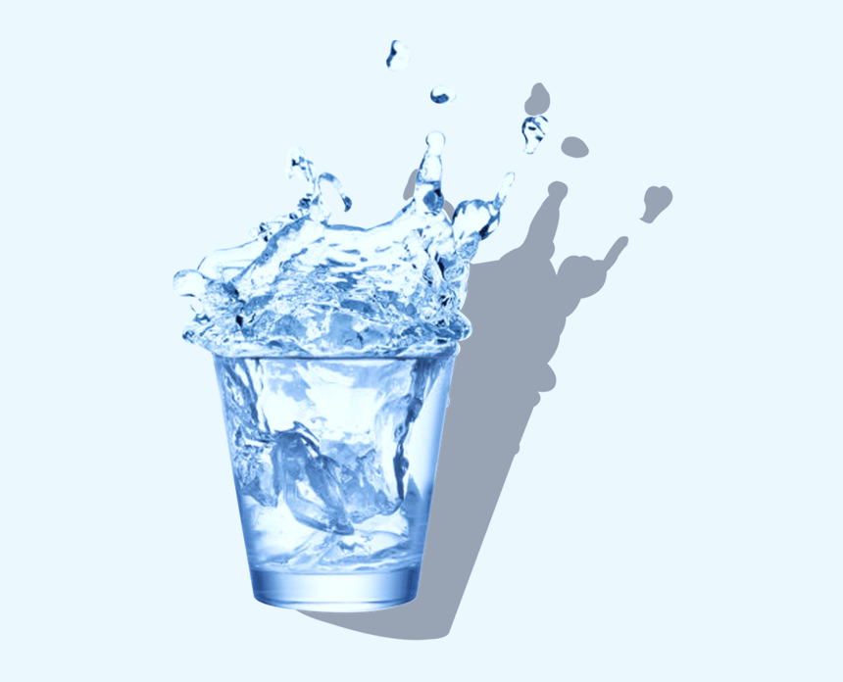

**WORLD**

**Try this now!**  
  
We are professional manufacturers of faucets (lavatory, kitchen, tub, and shower), with UPC, CPC, A321ADER Certifications

**HYDRO  
PRODUCT**